

**PROFIT DASHBOARD**

**1.Graph of gender and profit**

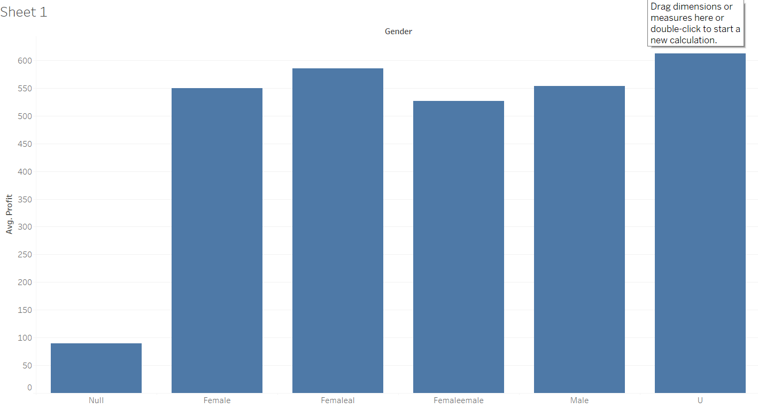

In this graph it is shown that female and male both have the equal interest of buying vehicals for their usage.

**2.Graph of Customer Id and profit**

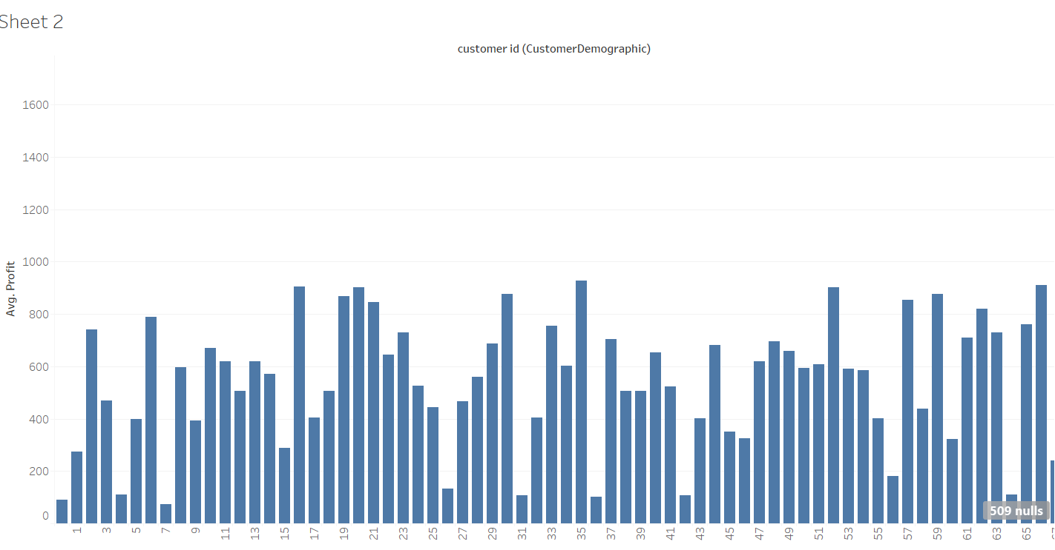

This is the graph of customer id and profit

**3.Graph of Brand and Profit**

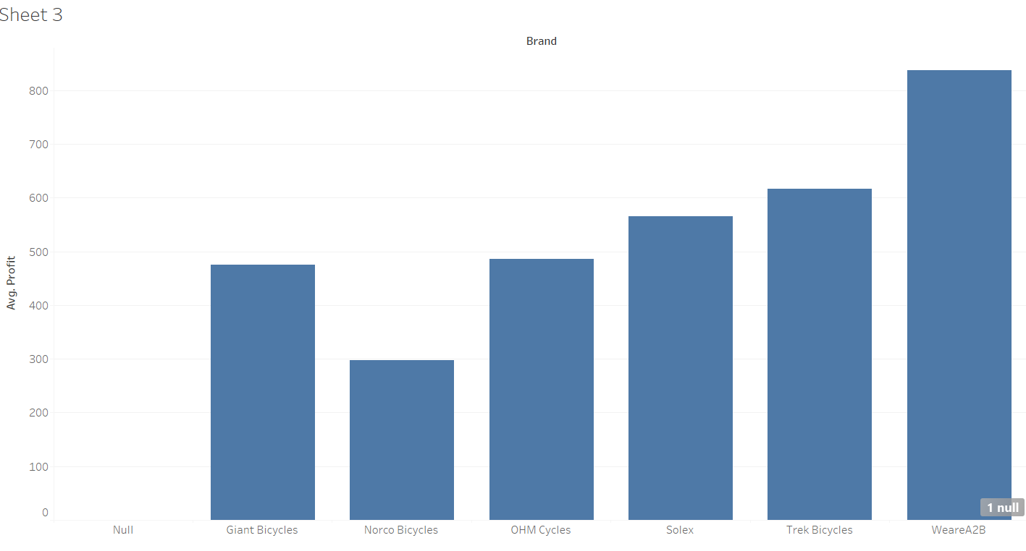

This is the graph between brand and profit which shows that WeareA2B is has more craze and also trek bicycles.So if they increase the sales of those brands it would be useful.

**4. Graph of month and profit**

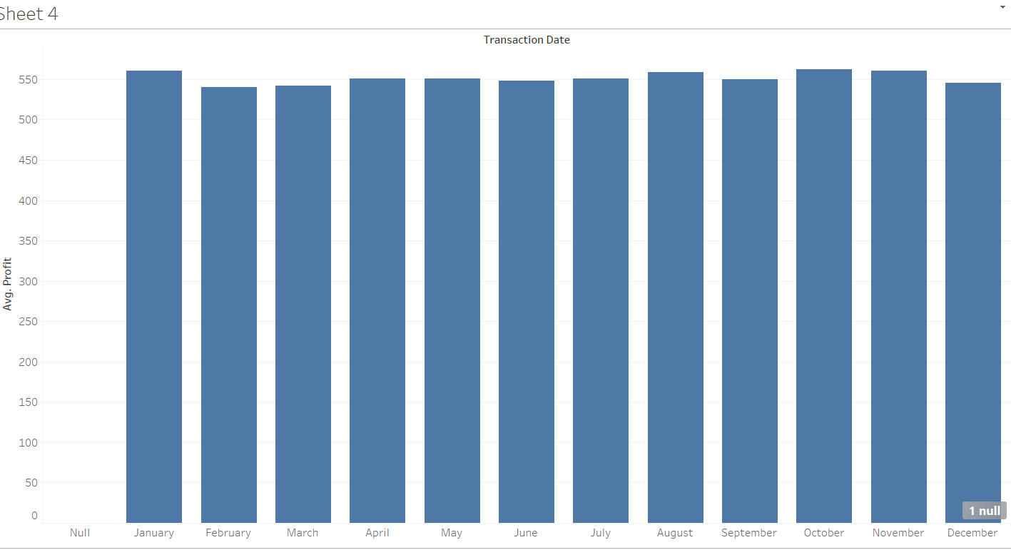

Here we can see that in which month we have more sales. In the month of January we saw more sales so if we increase products in those months it is really useful.

Dashboard: